**Djibouti country profile**

Published

8 May 2018

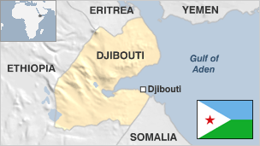

**Lying on the Bab el-Mandeb Strait, the tiny African nation of Djibouti serves as a gateway to the Suez Canal, one of the world's busiest shipping routes.**

Its port is the lifeblood of its economy, providing the biggest source of income and employment in this otherwise barren country.

Djibouti's proximity to restive areas in Africa and the Middle East and its relative stability have made it a prized location for foreign military bases and ensured a steady flow of foreign assistance.

Former colonial power France maintains a significant military presence. The country also hosts America's largest military base in Africa, China's first overseas military base and Japan's first military base since the Second World War.

Djibouti serves as the main gateway for trade for its giant neighbour, landlocked Ethiopia.

* Read more [country profiles](http://news.bbc.co.uk/1/hi/country_profiles/) - Profiles by [BBC Monitoring](http://bbc.co.uk/monitoring)

**President: Ismail Omar Guelleh**

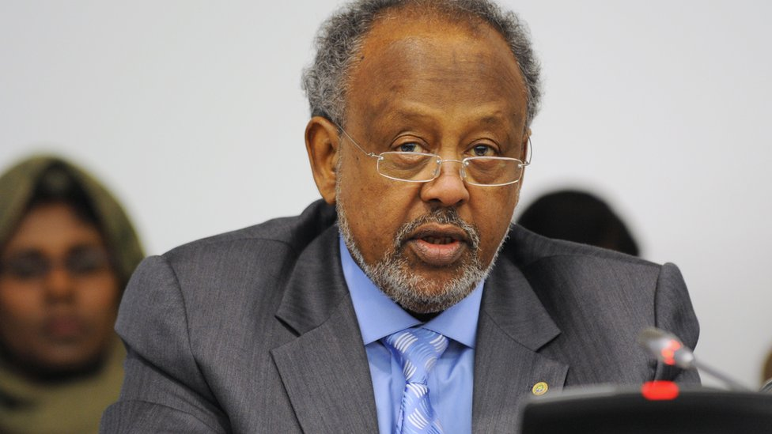image copyrightGetty Images

Ismail Omar Guelleh came to power in elections in 1999, succeeding Hassan Gouled Aptidon, who led the country for two decades since independence.

His re-election as president in 2005 was seen as somewhat of a formality given the opposition's boycott of the election.

He further consolidated his power when a change to the constitution in 2010 allowed him to stand for a third term. The 2011 presidential election was again boycotted by the opposition.

With no strong challenger, Mr Guelleh won a fourth term of office in the April 2016 presidential election.

Born in Ethiopia in 1947, Mr Guelleh, like his predecessor, belongs to the Mamassans, a sub-clan of the Issa. His family moved to Djibouti in 1960 and eight years later he joined the intelligence services, rising through the ranks to become head of state security in 1977.

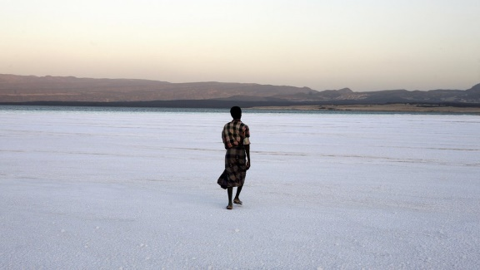image copyrightGetty Images

image captionDjibouti's saline Lake Assal lies 155 m below sea level, making it the lowest point on the continent. It is used for quarrying salt

Djibouti's media environment is dominated by the state. There are no private TV or radio stations and the government owns the main newspaper and the national broadcaster Radiodiffusion-Television de Djibouti (RTD).

Reporters Without Borders says local journalists "live in fear". The few opposition media outlets are based outside the country.

# Djibouti profile - Timeline

Published

8 May 2018

## A chronology of key events:

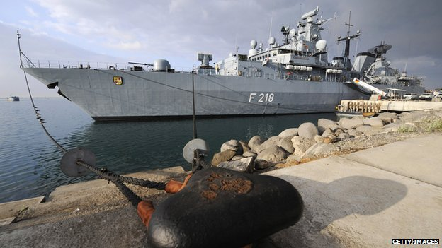image copyrightGetty Images

image captionDjibouti is used as a base by foreign forces tackling security issues within striking distance of the Horn of Africa, including terrorism and piracy

**825** - Islam introduced to the area.

## French rule

**1862** - France acquires the port of Obock.

**1888** - French colony of Somaliland established over the region.

**1892** - Djibouti becomes capital of French Somaliland.

**1897** - Ethiopia acquires parts of Djibouti after signing a treaty with France.

**1917** - Railway connecting the port of Djibouti with the Ethiopian hinterland reaches Addis Ababa.

**1946** - Djibouti made an overseas territory within the French Union with its own legislature and representation in the French parliament.

**1958** - Djibouti votes to join the French Community.

## Independence

**1967** - Referendum takes place during which Afar people and Europeans vote to remain part of the French Community; French Somaliland renamed the French Territory of the Afars and the Issas.

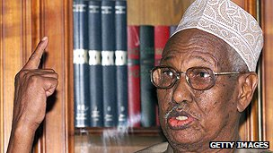image copyrightGetty Images

image captionHassan Gouled Aptidon became independent Djibouti's first president

**1977** - The French Territory of the Afars and the Issas becomes independent as Djibouti with Hassan Gouled Aptidon as president.

**1979** - People's Progress Assembly party set up with a view to uniting the Afar and Issa peoples.

**1981** - Djibouti becomes a one-party state with the People's Progress Assembly as the sole party.

**1992** - A constitution allowing for a limited multiparty system adopted; fighting erupts between government troops and the Afar Front for the Restoration of Unity and Democracy (FRUD) in the northeast of the country.

## Power-sharing agreement

**1994** - The government and the main faction of FRUD sign a power-sharing agreement officially ending the civil war; the radical faction of FRUD continues to fight.

**1995** - French Judge Bernard Borrel dies under mysterious circumstances in Djibouti. He was advising the Djibouti government, and reportedly investigating arms smuggling.

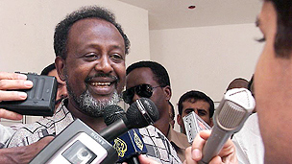image copyrightGetty Images

image captionPresident Guelleh won elections in 1999

**1999** - President Aptidon announces that he will not run in the presidential election; Ismael Omar Guelleh elected president.

**2000** February - The government and the radical faction of FRUD sign a peace agreement finally putting an end to the civil war.

**2000** March - Former Prime Minister and leader of the radical faction of FRUD Ahmed Dini returns to Djibouti after nine years in exile.

**2000** December - Coup attempt said to have been masterminded by sacked police chief General Yacin Yabeh Galab fails and Yacin charged with conspiracy and breaching state security.

**2002** January - German warships and 1,000 sailors arrive in Djibouti to patrol shipping lanes in Red Sea area, in support of US actions in Afghanistan.

**2002** September - 1992 law allowing only three other parties to compete with ruling party expires, paving way for full multi-party politics.

**2002** September - Djibouti says it won't be used as a base for attacks against another country in the region. Some 900 US troops set up camp in support of US-led war on terror.

**2003** January - Coalition supporting President Ismael Omar Gelleh - the Union for Presidential Majority - wins Djibouti's first free multi-party elections since independence in 1977.

## Anti-immigrant drive

**2003** September - Government begins drive to detain and expel illegal immigrants, thought to make up 15% of population.

**2005** April- Presidential elections: Incumbent President Guelleh is the sole candidate.

**2006** November - A UN report says several countries, including Djibouti, have flouted a 1992 arms embargo on Somalia by supplying the rival Islamist administration in Mogadishu. Djibouti denies the allegation.

**2007** March-April- Drought declared in some inland areas. United Nations World Food Programme (WFP) says some 53,000 people could go without food rations unless funding is found.

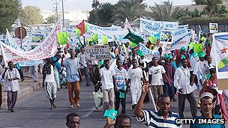image copyrightGetty Images

image captionDemonstrators took to the streets to hinder a probe into the death of a French judge

**2008** January - Djibouti begins legal battle with France in the International Court of Justice in The Hague over investigation into death of French judge Bernard Borrel.

**2008** February - Ruling coalition wins all 65 seats in parliamentary elections, which are boycotted by the three main opposition parties.

## Fighting with Eritrea

**2008** June- Fighting breaks out between Djiboutian and Eritrean troops in the disputed Ras Doumeira border area. At least nine Djiboutian soldiers killed. US condemns Eritrean "aggression" but Eritrea denies launching an attack.

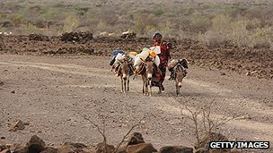image copyrightGetty Images

image captionThousands of people were affected by drought in 2011

**2009** December - UN Security Council approves tough sanctions against Eritrea for supplying weapons to opponents of the Somali government and refusing to resolve border dispute with Djibouti.

**2010** April - Parliament approves constitutional amendment allowing president to run for a third term.

**2010** June - Eritrea, Djibouti agree to resolve their border dispute peacefully.

## Opposition tensions

**2011** February - Thousands gather for rare protest demanding regime change. At least two people are killed in confrontation with police.

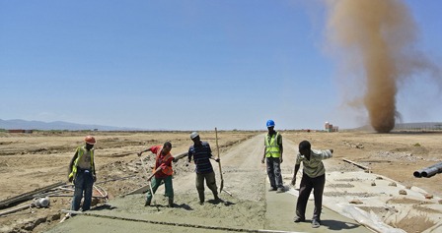image copyrightGetty Images

image captionWorkers on a construction site in north-eastern Ethiopia help restore Ethiopian rail access to the sea by reviving a link to Djibouti

**2011** April - Guelleh wins a third term as president in an election boycotted by the opposition.

**2011** June-September - Horn of Africa hit by worst drought in 60 years.

**2011** December - First consignment of troops from Djibouti arrives in Somali capital, Mogadishu, to bolster the African Union force there.

**2012** February - IMF approves $14 million loan to boost Djibouti's drought-hit finances.

**2013** February - Opposition groups contest parliamentary elections after their 2008 boycott. They reject the result, which gave the governing Union for the Presidential Majority 49 of 65 seats.

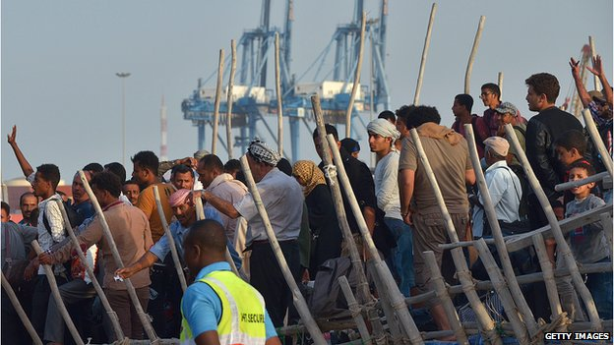image copyrightGetty Images

image captionThousands of refugees fleeing conflict in Yemen crossed by boat to Djibouti in 2015

**2014** May - Bomb blast in restaurant with several Western military personnel kills three, including two suicide bombers. Somali Islamist group al-Shabab claims responsibility.

**2014** June - Djibouti suffers its fourth straight year of drought, a UN official says.

**2015** December - Several people killed in clash with police in capital. Opposition accuses authorities of arresting supporters.

**2016** April - President Ismail Omar Guelleh gains fourth term of office following elections, having previously said he would not run for the presidency again.

**2016** July - The International Criminal Court says it has referred the governments of Djibouti and Uganda to the UN Security Council for failing to arrest Sudan's president, Omar al-Bashir.

**2016** December - Djibouti says Saudi Arabia is to set up a military base in the country.

**2017** June - Djibouti accuses Eritrea of sending troops into a disputed area on the border, following the withdrawal of Qatari peacekeepers.

**2017** August - China formally opens its first overseas military base in Djibouti.